**DEPARTMENT OF COMPUTER & SOFTWARE ENGINEERING**

**COLLEGE OF E&ME, NUST, RAWALPINDI**

Digital Image Processing

Assignment #02

**Student Name: Muhammad Hamza Tariq – 371070**

**Degree/ Syndicate: 43 CE B**

Retinal Image Segmentation and Objects Analysis

**Introduction**

The aim of this assignment is to use knowledge about spatial enhancement and segmentation to extract optic disc from given images.

**Understanding the Assignment**

**Assignment Overview**

The assignment at hand pertains to **Digital Image Processing** focusing on retinal image analysis, specifically targeting the segmentation and analysis of objects within fundus images.

**Key Objectives**

* **Spatial Enhancement and Filtering:** Employing transformation and filtering techniques for spatial enhancement.
* **Segmentation:** Extracting specific objects, particularly the optic disc, from fundus images.
* **Error Analysis:** Evaluating the accuracy of segmentation through error calculation.

**Spatial Enhancement and Filtering**

Spatial enhancement techniques involving transformation and image filtering play a vital role in preprocessing fundus images. These techniques aim to enhance specific features and improve the overall quality of the images, thereby facilitating subsequent analysis tasks.

**Segmentation of Optic Disc**

**Understanding Fundus Images**

Fundus images, capturing the retina's inner surface, serve as crucial diagnostic tools for various retinal diseases. Key landmarks within these images include the optic disc, blood vessels, and fovea.

**Optic Disc Extraction**

The primary objective of the assignment is to extract the optic disc from fundus images using spatial enhancement and segmentation techniques. This process involves identifying and isolating the bright region corresponding to the optic disc while mitigating potential false positives from other bright lesions.

**Algorithmic Approach**

1. **pre_process_image**:
   * Explanation: This function resizes an image to a specified size and returns the resized image along with the scaling factor used for resizing.
   * Working: It calculates the scaling factor required to resize the image to the desired size. Then, it resizes the image using OpenCV's **cv2.resize** function and returns the resized image along with the scaling factor.
2. **extract_vessels**:
   * Explanation: This function extracts blood vessels from a retinal image using image processing techniques.
   * Working: It converts the input image to grayscale, applies Gaussian blur and Canny edge detection to detect edges of blood vessels. Then, it uses connected component analysis to identify connected regions (vessels) and filters out small components based on the minimum component area.
3. **find_brightest_spots**:
   * Explanation: This function finds the brightest spots in an image, typically representing potential locations of the optic disc.
   * Working: It converts the input image to grayscale, applies Gaussian blur, and performs thresholding to identify bright regions. Then, it finds contours of these regions and selects the largest ones as the brightest spots.
4. **find_intersection_point**:
   * Explanation: This function detects the intersection point of blood vessels in an image, which often corresponds to the location of the optic disc.
   * Working: It applies morphological operations to the input image to close gaps between vessel segments. Then, it finds contours and calculates the centroid of the largest contour as the intersection point.
5. **analyze_data**:
   * Explanation: This function analyzes the characteristics of bright spots in an image, including intensity, vessel count, and distance from the intersection point.
   * Working: It iterates over each bright spot, masks the image around the spot, and calculates intensity and vessel count. It also calculates the distance from the intersection point and counts neighboring spots within a certain radius.
6. **find_best_spot**:
   * Explanation: This function identifies the best candidate spot for the optic disc based on vessel count, intensity, distance from the intersection point, and the number of neighboring spots.
   * Working: It sorts the information of each spot based on specified criteria and returns the center of the spot with the highest score, which is considered the best candidate for the optic disc.

**Detailed Flow Diagram**

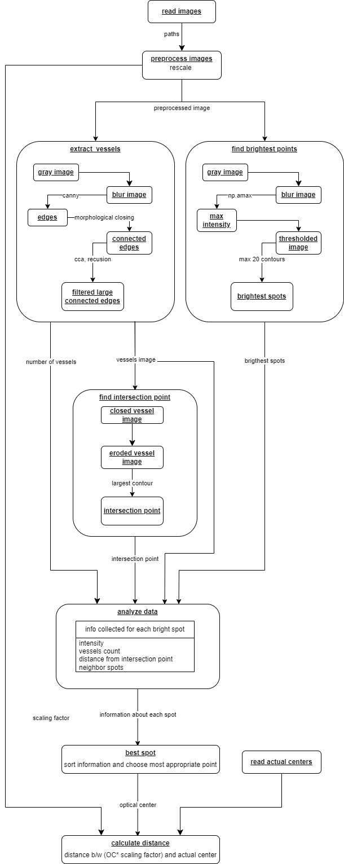

**Example information about spot table:**

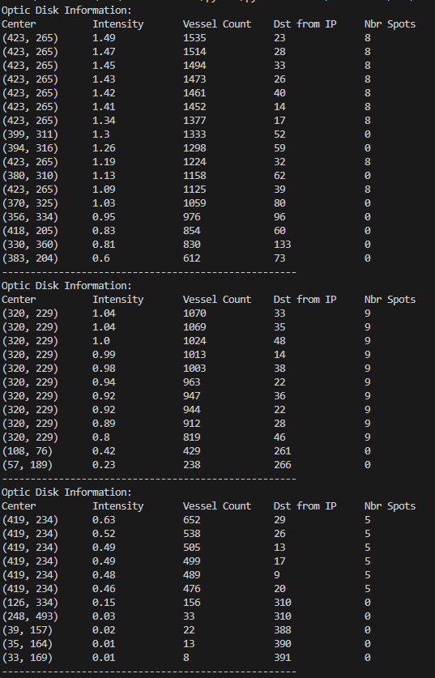

**Results:**

|  |  |  |  |  |
| --- | --- | --- | --- | --- |
| **Sr no.** | **Image** | **Derived OC** | **Actual OC** | **Distance** |
| **1** | 02_test.tif | (466, 302) | (458, 275) | 28.16 |
| **2** | 04_test.tif | (353, 261) | (361, 275) | 16.12 |
| **3** | 06_test.tif | (462, 266) | (461, 268) | 2.24 |
| **4** | 08_test.tif | (455, 278) | (485, 277) | 30.02 |
| **5** | 10_left.jpeg | (2208, 2023) | (2439, 1697) | 399.55 |
| **6** | 10_right.jpeg | (3331, 2320) | (2985, 1562) | 833.23 |
| **7** | 10_test.tif | (472, 277) | (468, 278) | 4.12 |
| **8** | 12_test.tif | (94, 233) | (82, 257) | 26.83 |
| **9** | 13_left.jpeg | (486, 960) | (504, 832) | 129.26 |
| **10** | 13_right.jpeg | (2080, 842) | (2119, 852) | 40.26 |
| **11** | 13_test.tif | (472, 273) | (486, 268) | 14.87 |
| **12** | 14_test.tif | (423, 449) | (479, 275) | 182.79 |
| **13** | 15_test.tif | (201, 318) | (193, 282) | 36.88 |
| **14** | 16_test.tif | (477, 295) | (479, 258) | 37.05 |
| **15** | 17_left.jpeg | (1450, 1042) | (1396, 1322) | 285.16 |
| **16** | 17_test.tif | (476, 279) | (467, 267) | 15 |
| **17** | 18_test.tif | (451, 277) | (471, 262) | 25 |
| **18** | 19_left.jpeg | (1427, 1306) | (1445, 1176) | 131.24 |
| **19** | 19_right.jpeg | (2376, 1280) | (2456, 1269) | 80.75 |
| **20** | 19_test.tif | (483, 281) | (486, 275) | 6.71 |
| **21** | 1ffa92e4-8d87-11e8-9daf-6045cb817f5b..JPG | (584, 1529) | (541, 1530) | 43.01 |
| **22** | 1ffa92fb-8d87-11e8-9daf-6045cb817f5b..JPG | (1118, 944) | (2620, 1343) | 1554.09 |
| **23** | 1ffa9309-8d87-11e8-9daf-6045cb817f5b..JPG | (1219, 1039) | (609, 1167) | 623.28 |
| **24** | 1ffa9523-8d87-11e8-9daf-6045cb817f5b..JPG | (684, 1085) | (652, 1070) | 35.34 |
| **25** | 1ffa952f-8d87-11e8-9daf-6045cb817f5b..JPG | (2546, 1255) | (2523, 1246) | 24.7 |
| **26** | 1ffa9555-8d87-11e8-9daf-6045cb817f5b..JPG | (452, 1436) | (512, 1501) | 88.46 |
| **27** | 20_left.jpeg | (2513, 1508) | (2539, 1513) | 26.48 |
| **28** | 20_right.jpeg | (1306, 1285) | (1293, 1296) | 17.03 |
| **29** | 20_test.tif | (482, 280) | (482, 284) | 4 |
| **30** | 21_left.jpeg | (1327, 2493) | (1724, 1589) | 987.33 |
| **31** | 21_right.jpeg | (3146, 1404) | (3036, 1556) | 187.63 |
| **32** | 21_training.tif | (173, 163) | (77, 257) | 134.36 |
| **33** | 22_left.jpeg | (810, 821) | (747, 848) | 68.54 |
| **34** | 22_right.jpeg | (1855, 873) | (1821, 910) | 50.25 |
| **35** | 22_training.tif | (494, 282) | (471, 272) | 25.08 |
| **36** | 23_left.jpeg | (1306, 1078) | (1417, 1127) | 121.33 |
| **37** | 23_right.jpeg | (2073, 597) | (2676, 1242) | 882.97 |
| **38** | 23_training.tif | (343, 344) | (428, 227) | 144.62 |
| **39** | 24_training.tif | (484, 257) | (472, 289) | 34.18 |
| **40** | 25_left.jpeg | (2543, 1442) | (2635, 1455) | 92.91 |
| **41** | 25_right.jpeg | (896, 1817) | (791, 1846) | 108.93 |
| **42** | 25_training.tif | (466, 278) | (464, 270) | 8.25 |
| **43** | 26_training.tif | (101, 236) | (80, 245) | 22.85 |
| **44** | 27_training.tif | (483, 287) | (492, 283) | 9.85 |
| **45** | 29_training.tif | (496, 293) | (497, 271) | 22.02 |
| **46** | 30_training.tif | (470, 292) | (492, 291) | 22.02 |
| **47** | 31_left.jpeg | (3214, 2932) | (1665, 1542) | 2081.23 |
| **48** | 31_right.jpeg | (3715, 1402) | (3366, 1536) | 373.84 |
| **49** | 31_training.tif | (399, 268) | (393, 250) | 18.97 |
| **50** | 32_training.tif | (472, 288) | (491, 285) | 19.24 |
| **51** | 33_left.jpeg | (2512, 2639) | (1657, 1592) | 1351.75 |
| **52** | 33_training.tif | (460, 292) | (470, 305) | 16.4 |
| **53** | 34_training.tif | (273, 281) | (388, 223) | 128.8 |
| **54** | 35_training.tif | (101, 272) | (81, 276) | 20.4 |
| **55** | 37_training.tif | (499, 288) | (496, 292) | 5 |
| **56** | 38_training.tif | (500, 280) | (490, 274) | 11.66 |

**Outputs:**

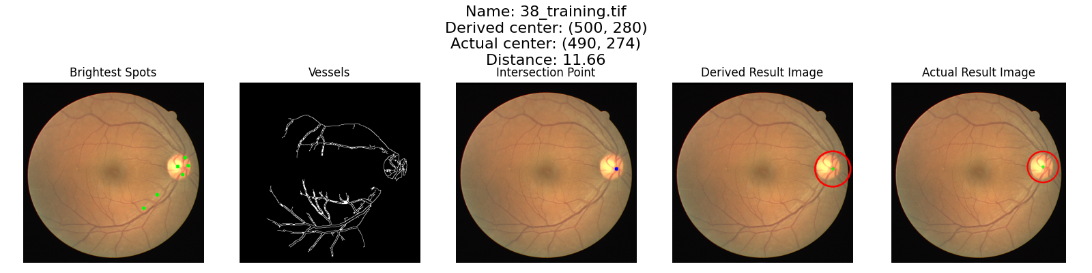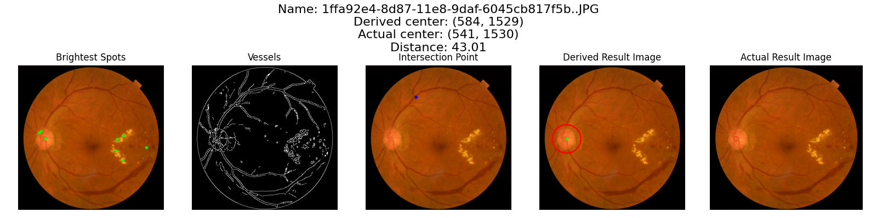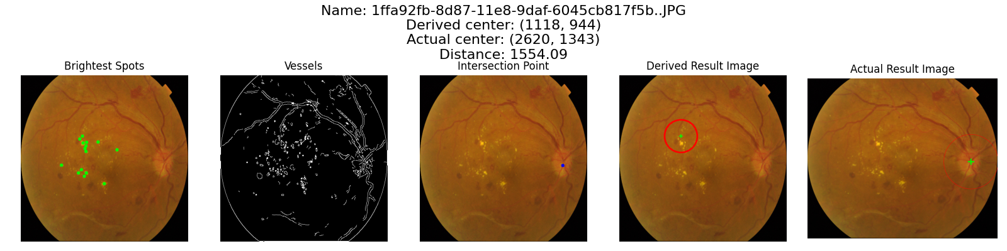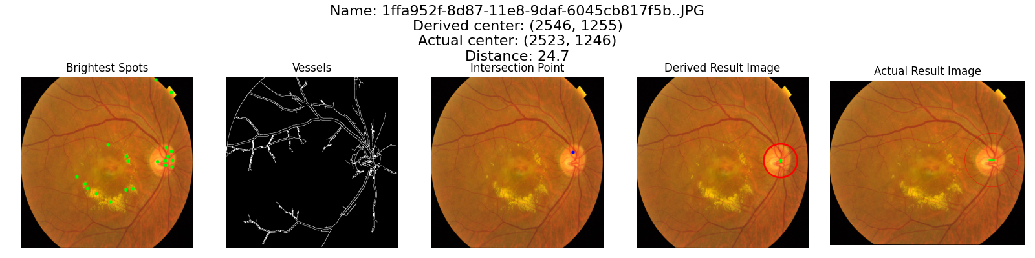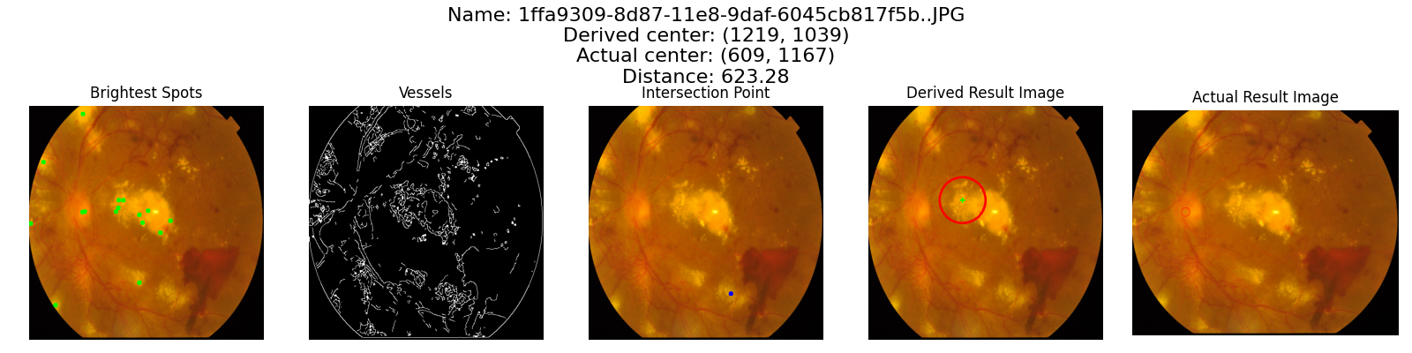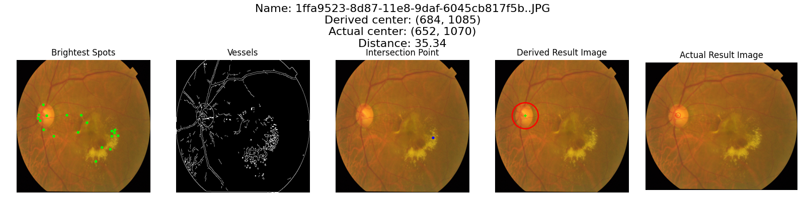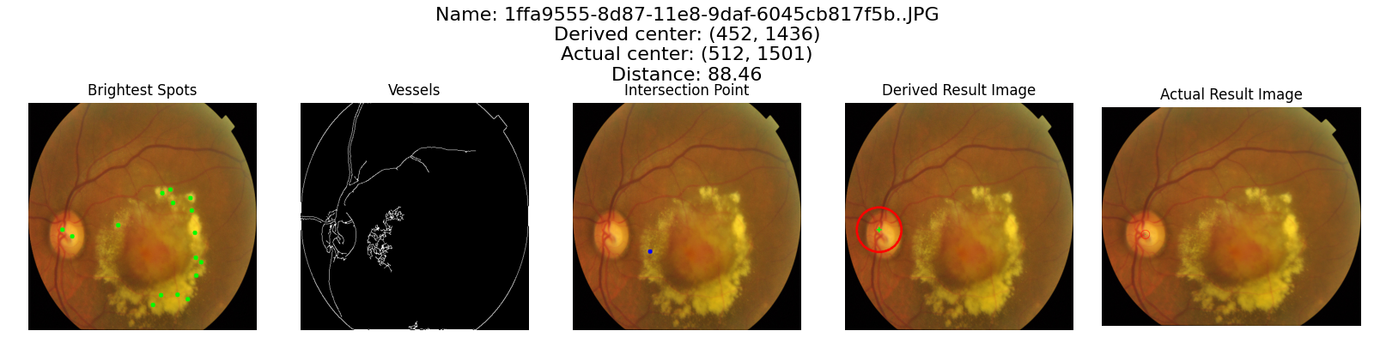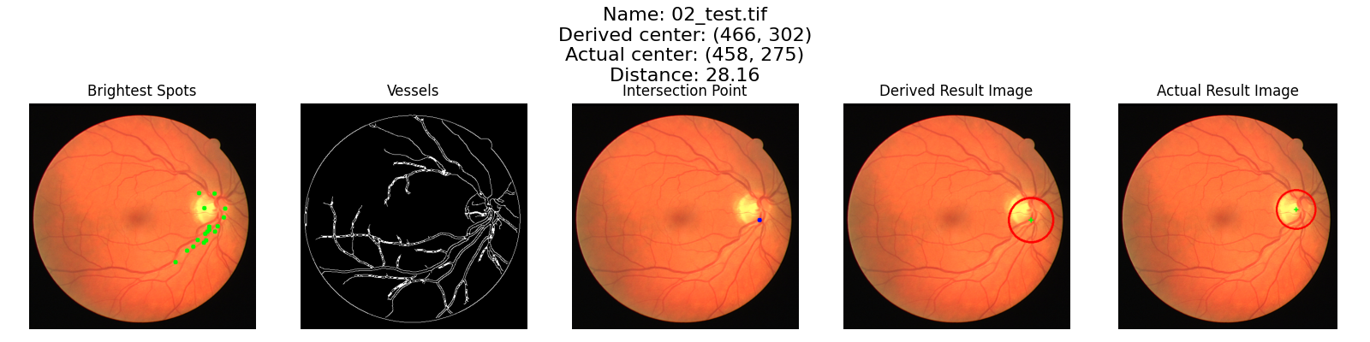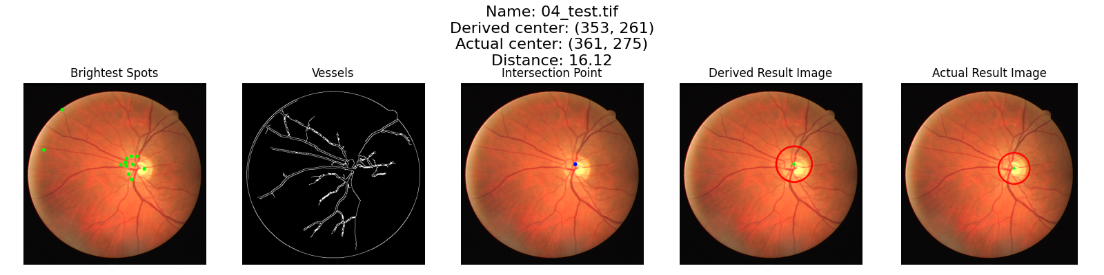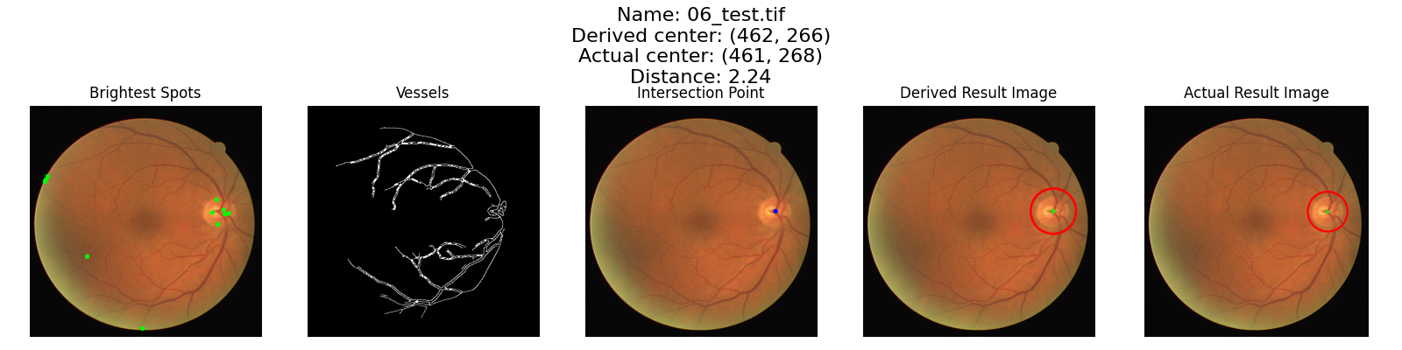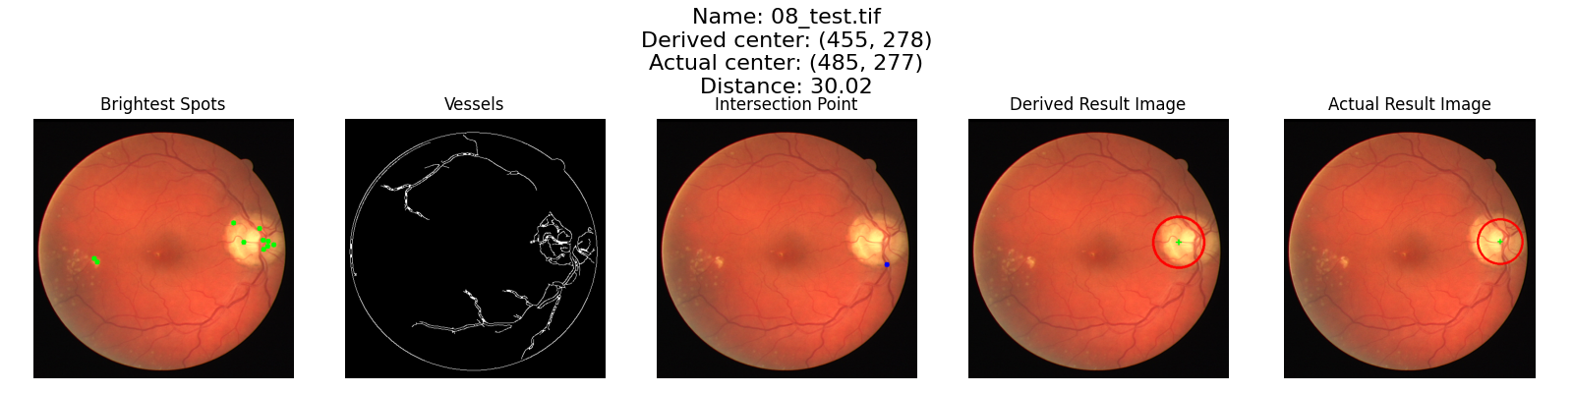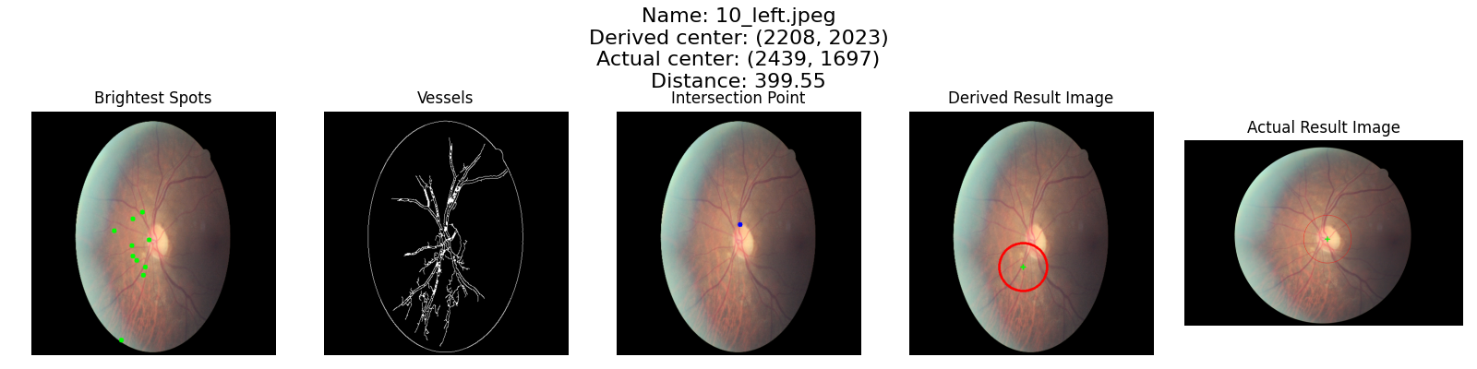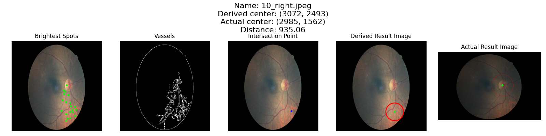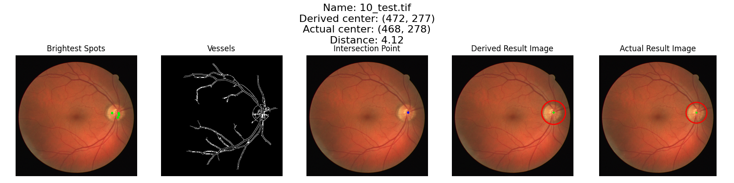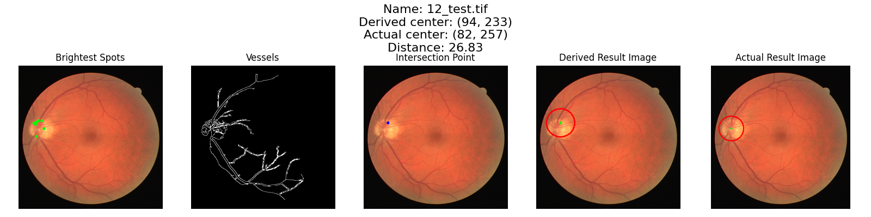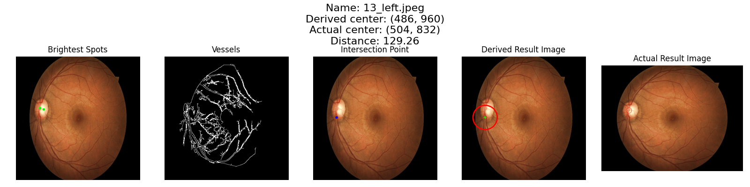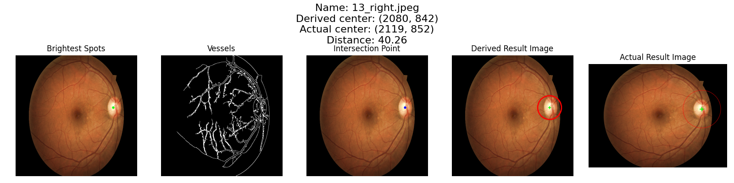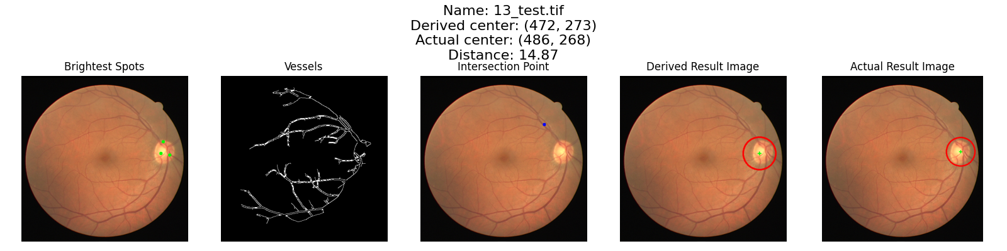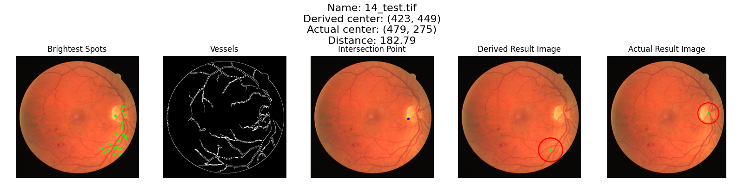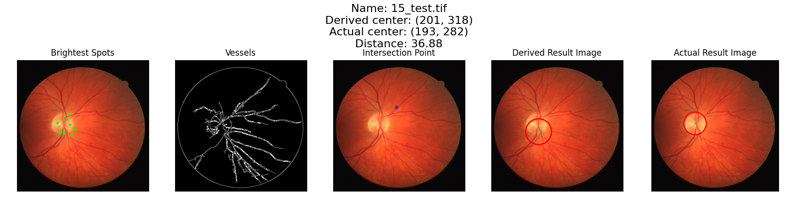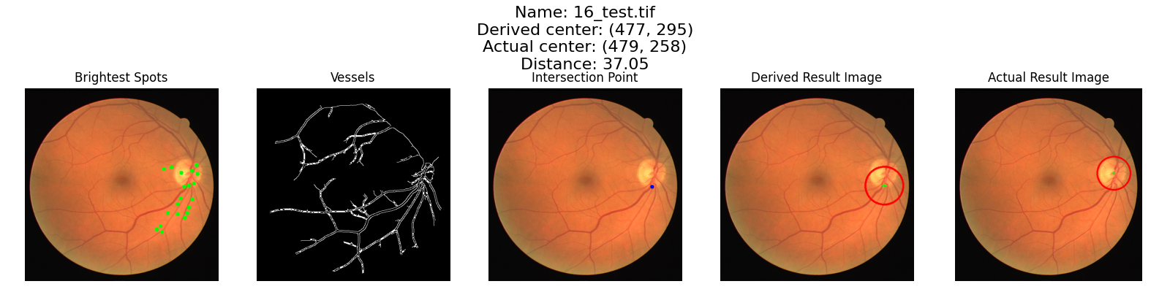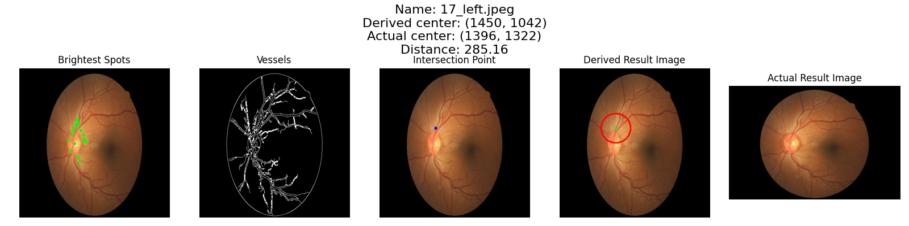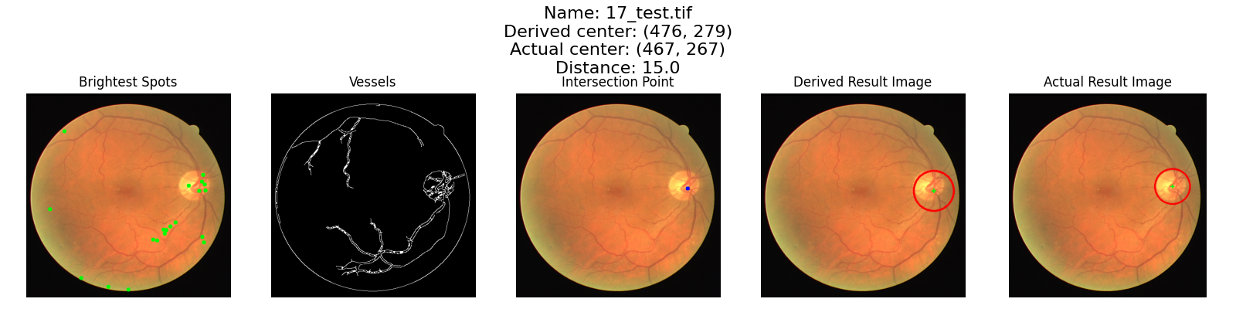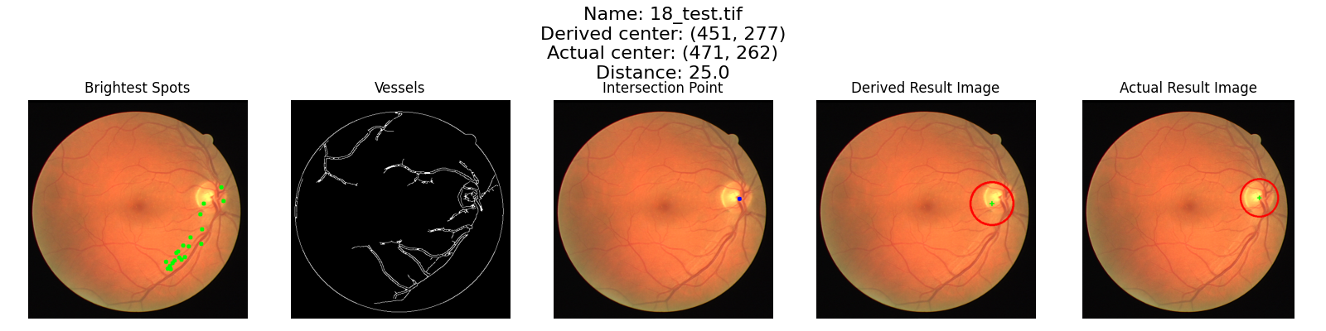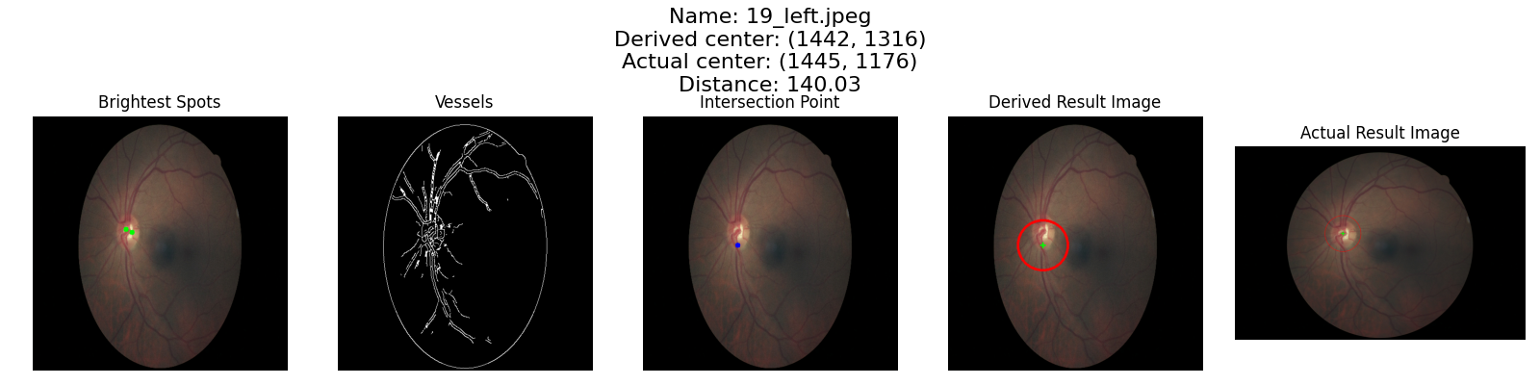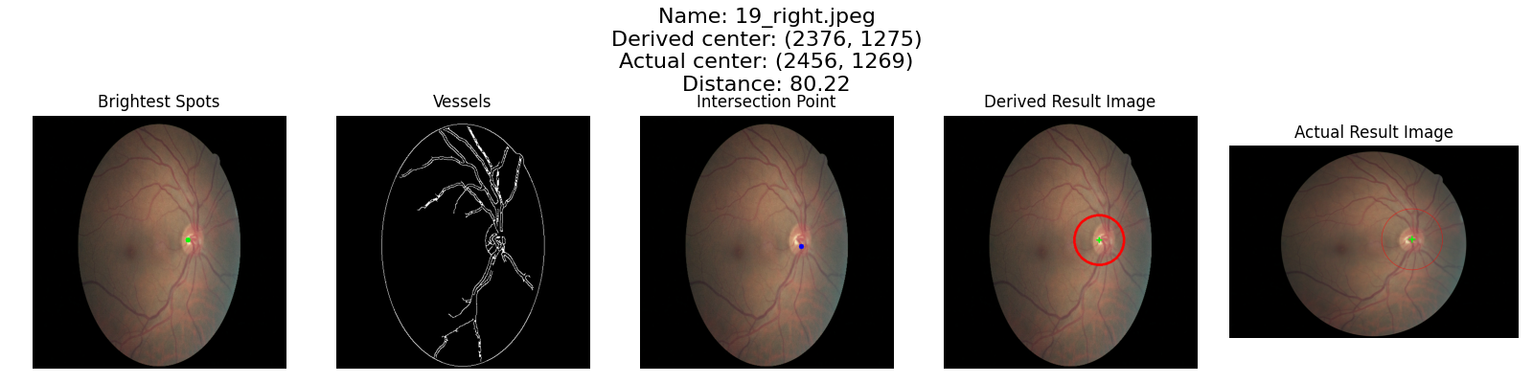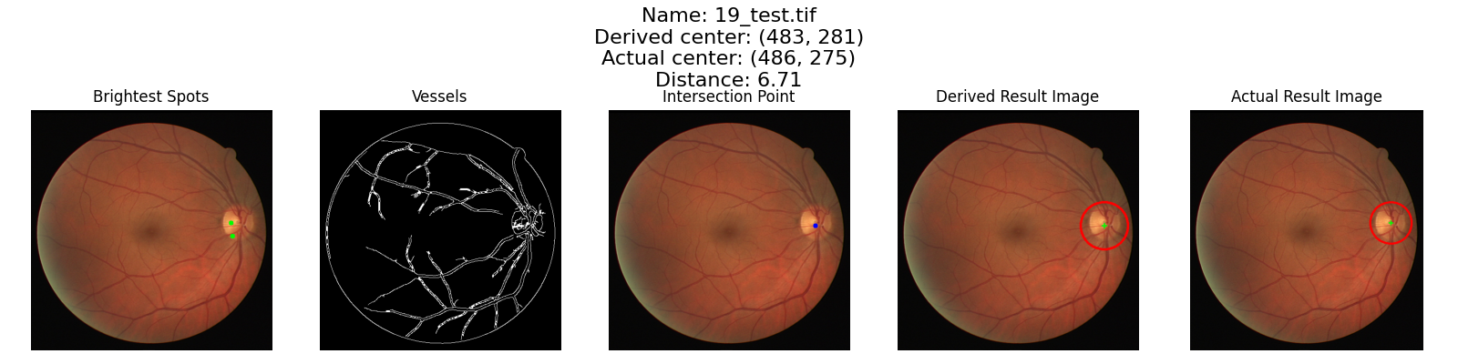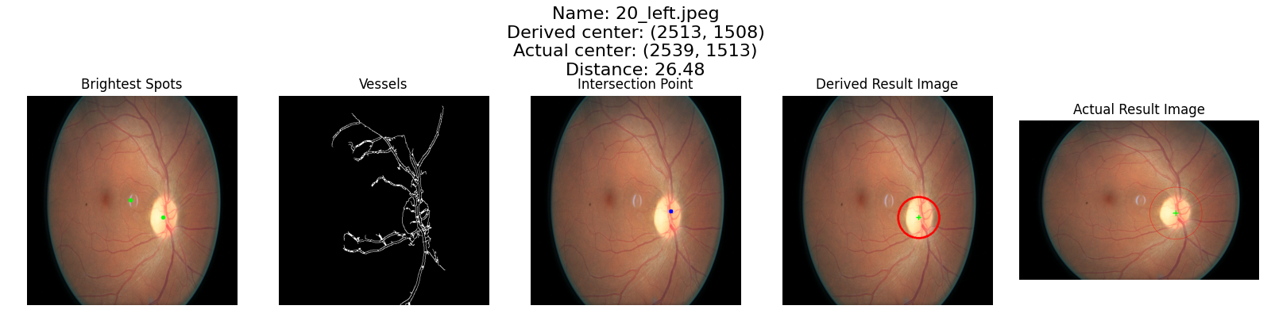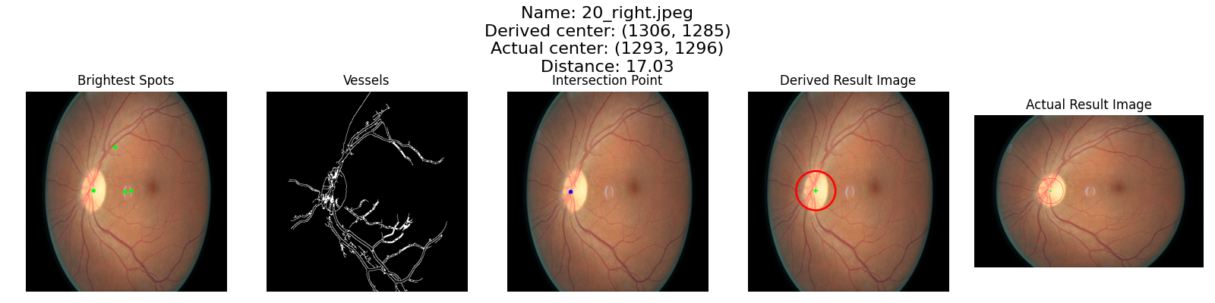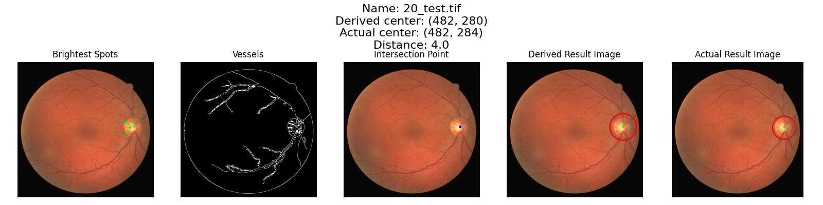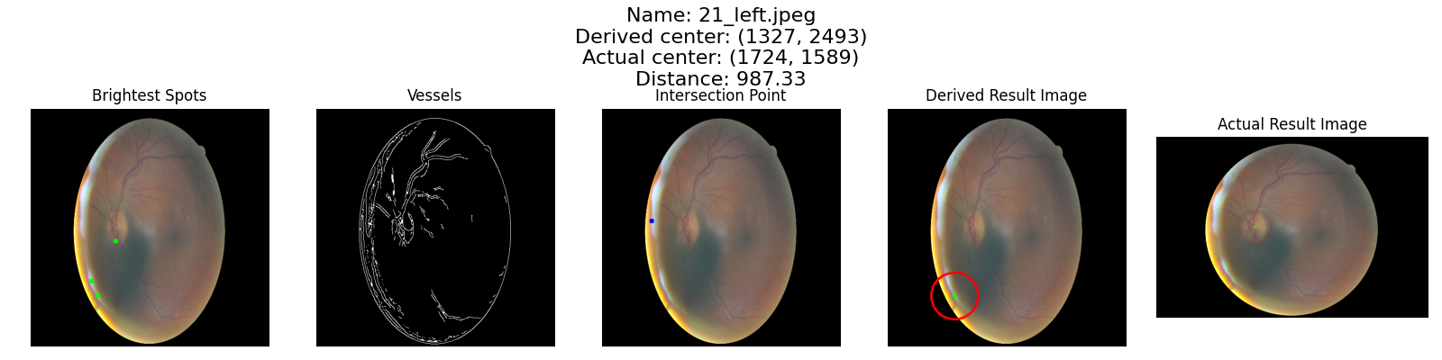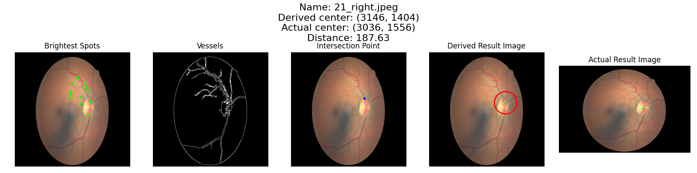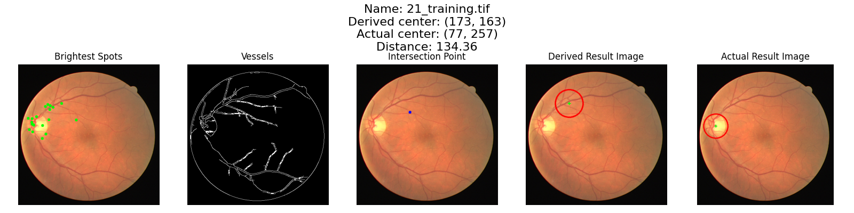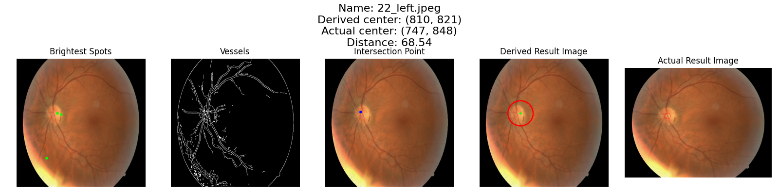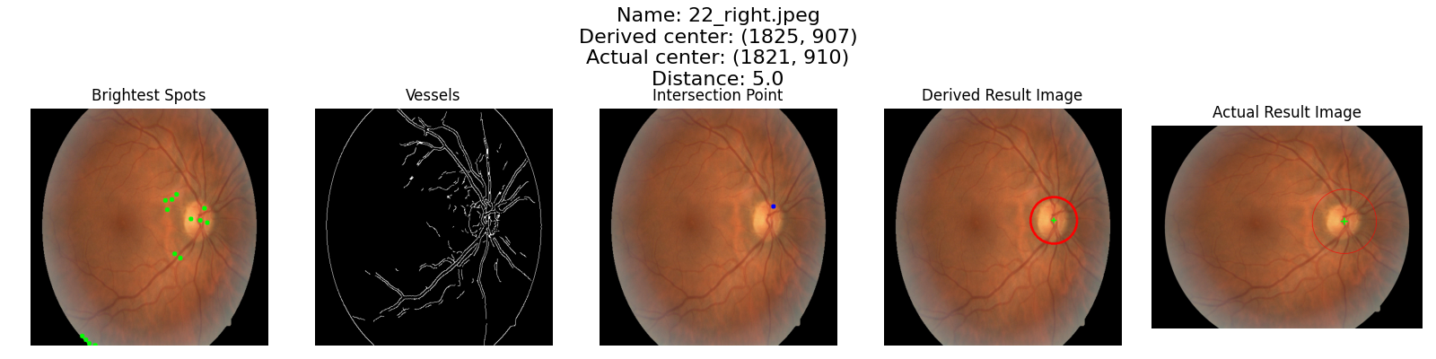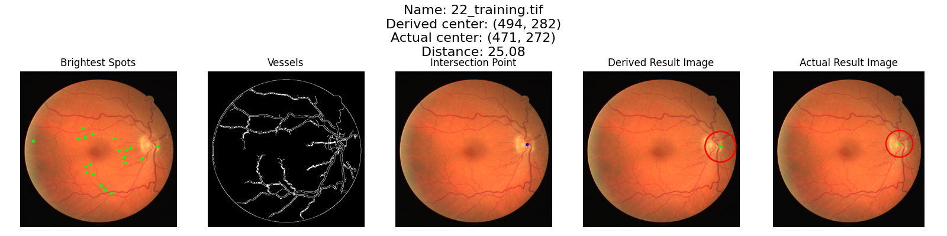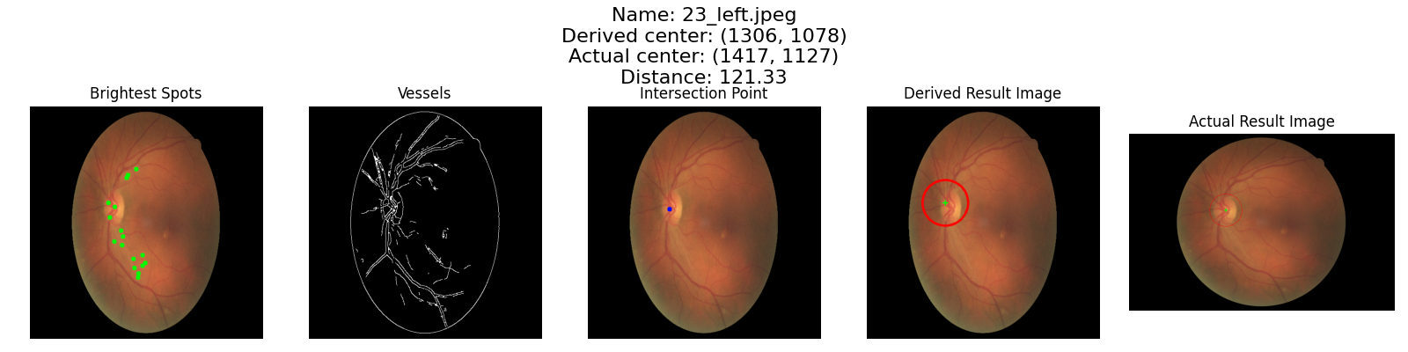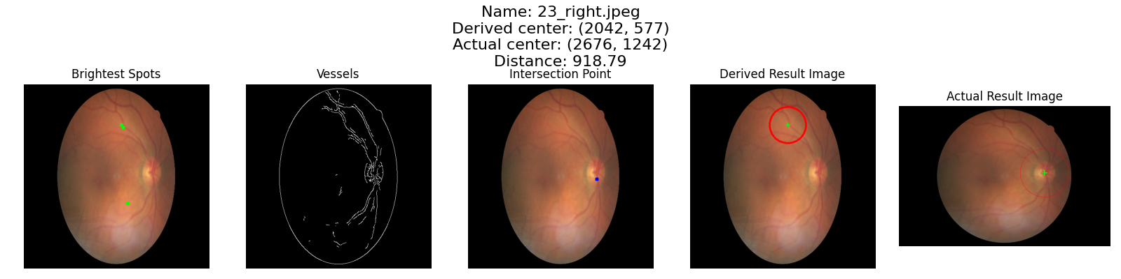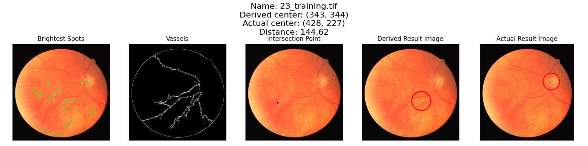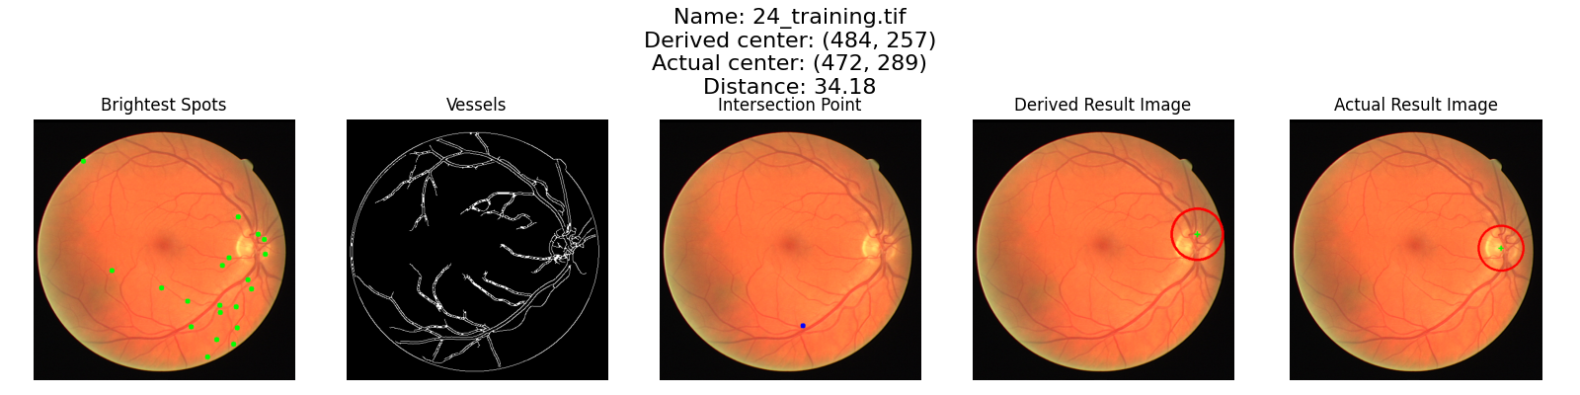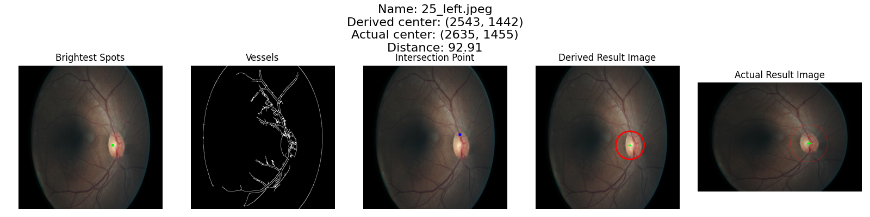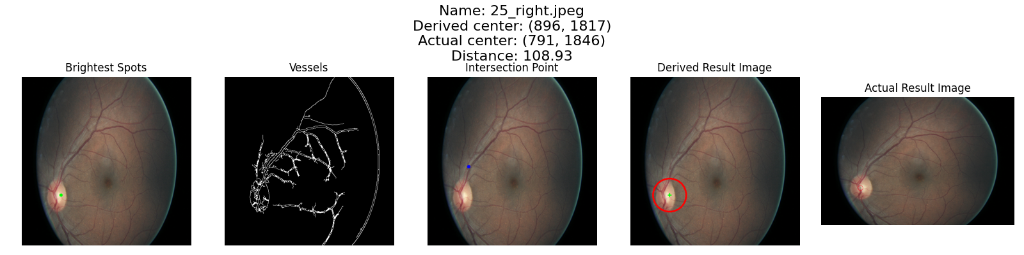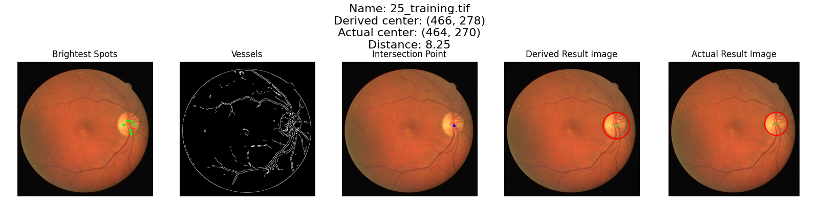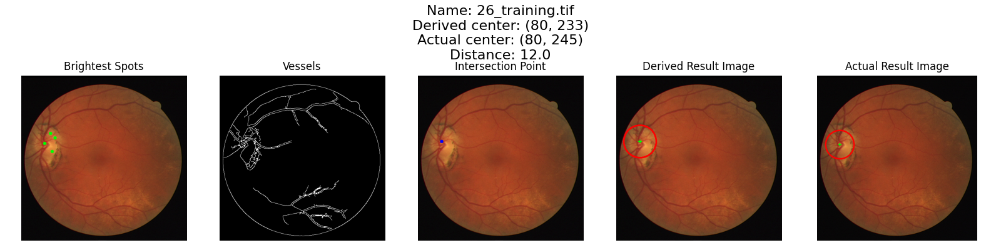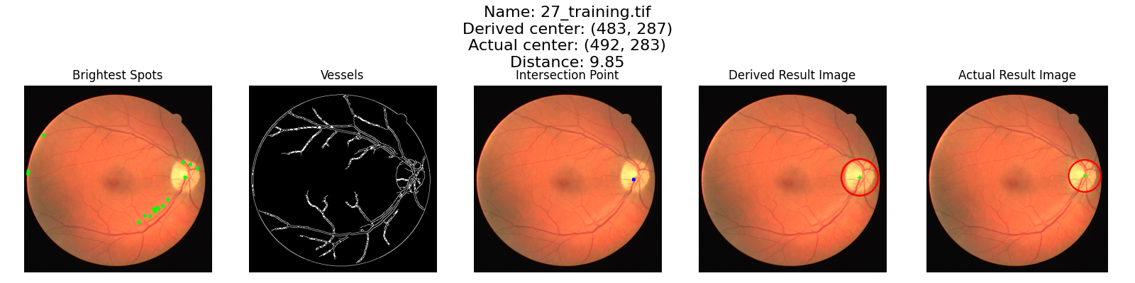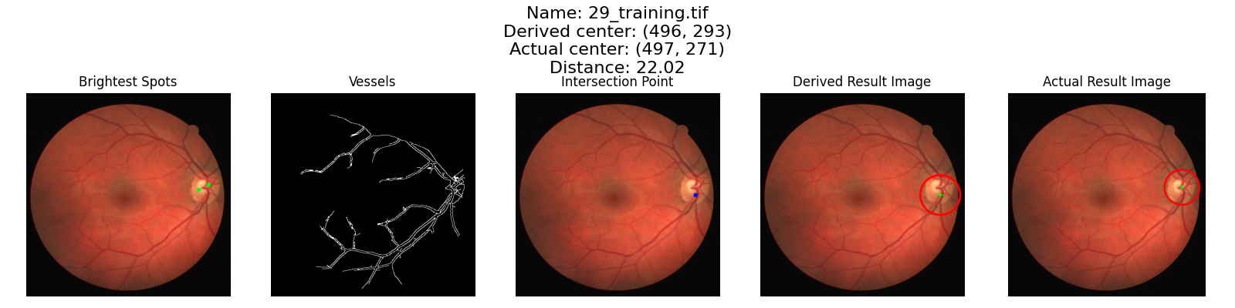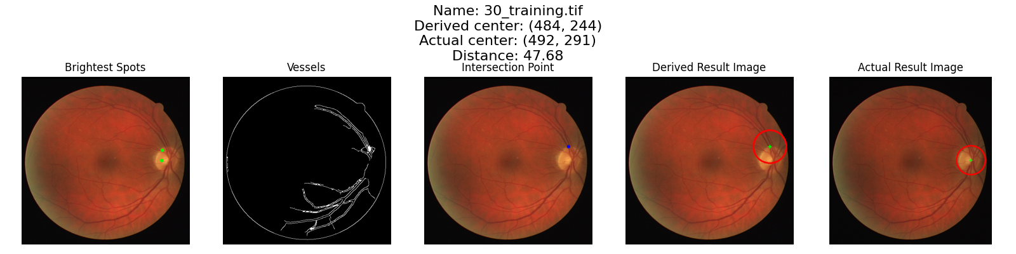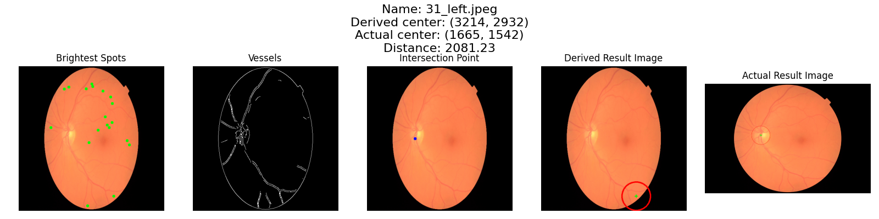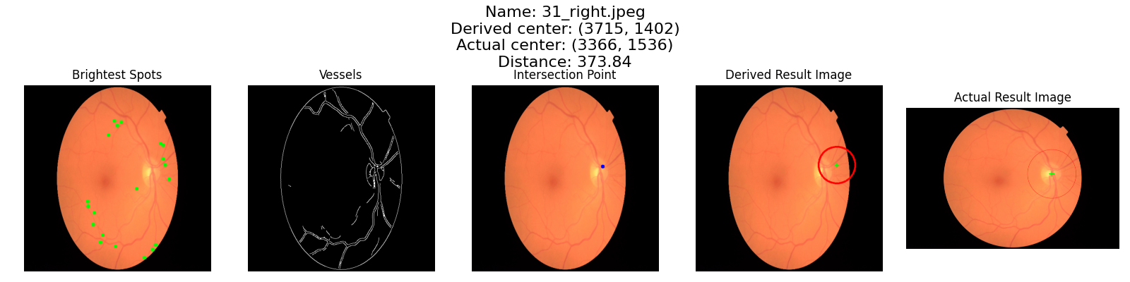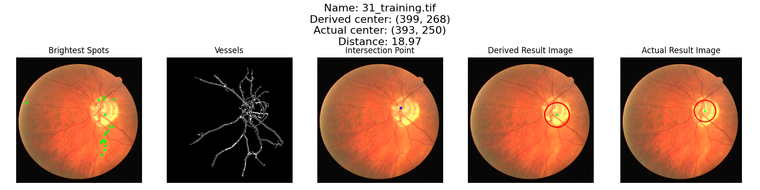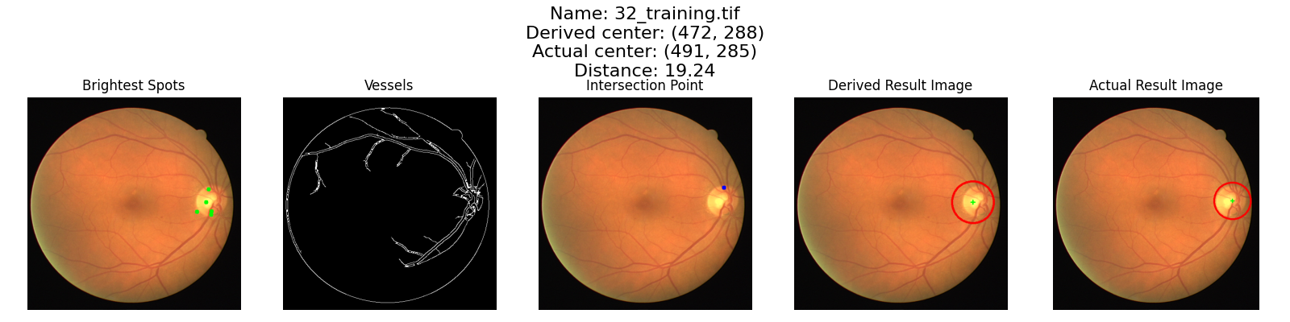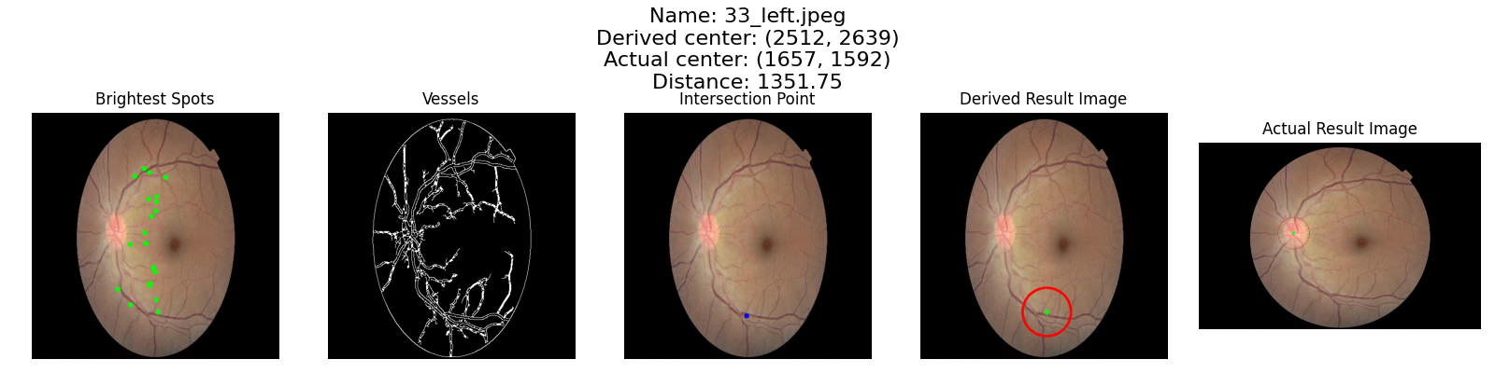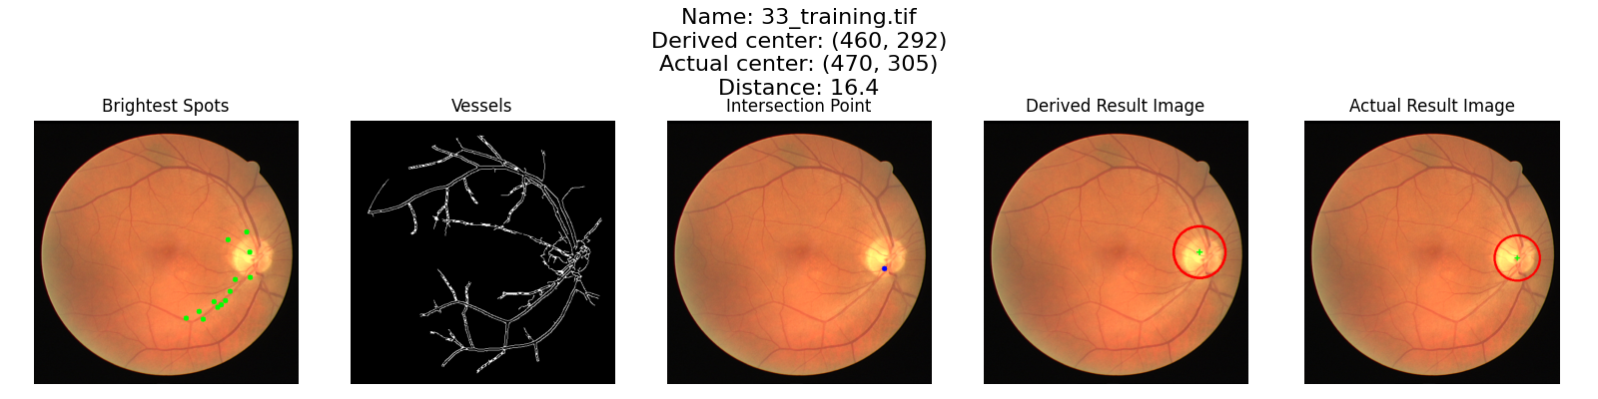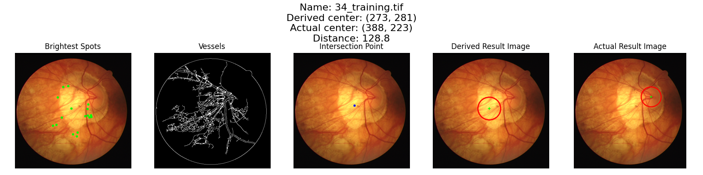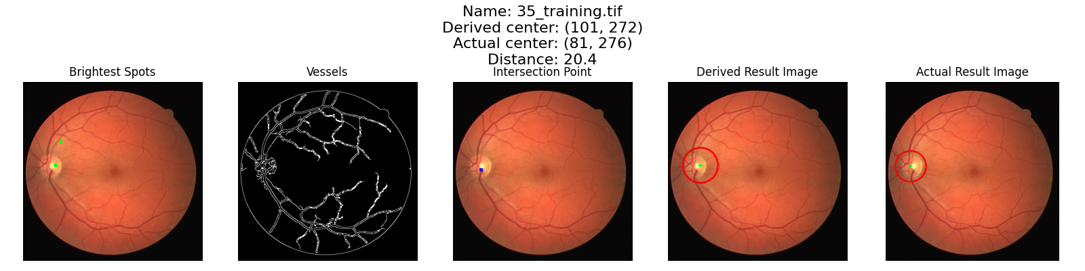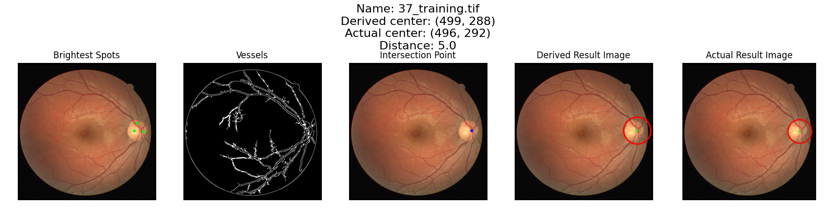

**Code:**

*import* os

*import* cv2

*import* csv

*import* numpy *as* np

*from* matplotlib.image *import* imread

*import* matplotlib.pyplot *as* plt

def read_images_from_folders(*folder_path*):

    images = []

    names = []

    files = os.listdir(*folder_path*)

    files.sort()

*for* file *in* files:

        path = os.path.join(*folder_path*, file)

        names.append(file)

        path = path.replace("\\", "/")

        images.append(path)

*return* images,names

def read_image_centers(*file_path*):

    centers = []

*with* open(*file_path*, 'r') *as* file:

*for* line *in* file:

            line = line.strip()

*if* line:

                parts = line.split(',')

*if* len(parts) == 3:

                    x = int(parts[1].strip())

                    y = int(parts[2].strip())

                    centers.append((x, y))

*return*  centers

def pre_process_image(*image*, *new_size*=(512, 512)):

    original_size = *image*.shape[:2]

    target_size = *new_size*

    scaling_factor = (target_size[1] / original_size[1], target_size[0] / original_size[0])

    resized_image = cv2.resize(*image*, *new_size*)

*return* resized_image, scaling_factor

def extract_vessels(*image*, *min_component_area*=2500):

    structure_element = cv2.getStructuringElement(cv2.MORPH_ELLIPSE, (3, 3))

    grayscale_image = cv2.cvtColor(*image*, cv2.COLOR_BGR2GRAY)

    blur_image = cv2.GaussianBlur(grayscale_image, (5, 5), 0)

    edges = cv2.Canny(blur_image, 30, 20)

    connected_edges = cv2.morphologyEx(edges, cv2.MORPH_CLOSE, structure_element)

    num_labels, labels, stats, centroids = cv2.connectedComponentsWithStats(connected_edges, *connectivity*=8, *ltype*=cv2.CV_32S)

*for* label *in* range(1, num_labels):

*if* stats[label, cv2.CC_STAT_AREA] < *min_component_area*:

            connected_edges[labels == label] = 0

    output = connected_edges

    num_vessels = cv2.countNonZero(connected_edges)

*# print('number of vessels found: ', num_vessels)*

*if* num_vessels < 6000:

*if* *min_component_area* < 500:

*# print('less vessels found, s < 500 ')*

*return* output,num_vessels

*elif* *min_component_area* < 1100:

*# print('less vessels found, s < 1100')*

            output,num_vessels = extract_vessels(*image*, *min_component_area*-500)

*else*:

*# print('less vessels found, s = 2500')*

            output,num_vessels = extract_vessels(*image*, *min_component_area*-1500)

*return* output, num_vessels

def find_brightest_spots(*image*):

    gray_image = cv2.cvtColor(*image*, cv2.COLOR_BGR2GRAY)

    blurred_image = cv2.GaussianBlur(gray_image, (5, 5), 0)

    max_intensity = np.amax(blurred_image)

    _, thresholded_image = cv2.threshold(blurred_image, max_intensity * 0.7, 255, cv2.THRESH_BINARY)

    contours, _ = cv2.findContours(thresholded_image, cv2.RETR_EXTERNAL, cv2.CHAIN_APPROX_SIMPLE)

    contours = sorted(contours, *key*=cv2.contourArea, *reverse*=True)[:20]

    bright_spots = []

*for* contour *in* contours:

        x, y, w, h = cv2.boundingRect(contour)

        center_x = x + w // 2

        center_y = y + h // 2

        bright_spots.append((center_x, center_y))

*return* bright_spots

def find_intersection_point(*image*):

    structure_element = cv2.getStructuringElement(cv2.MORPH_ELLIPSE, (7, 7))

    closed_image = cv2.morphologyEx(*image*, cv2.MORPH_CLOSE, structure_element)

    eroded_image = cv2.erode(closed_image, structure_element)

    contours, _ = cv2.findContours(eroded_image, cv2.RETR_EXTERNAL, cv2.CHAIN_APPROX_SIMPLE)

*if* contours:

        largest_contour = max(contours, *key*=cv2.contourArea)

        M = cv2.moments(largest_contour)

*if* M["m00"] != 0:

            center_x = int(M["m10"] / M["m00"])

            center_y = int(M["m01"] / M["m00"])

            intersection_point = (center_x, center_y)

*return* intersection_point

*return* None

def analyze_data(*image*, *brightest_spots*,*intersection_point*,*count*, *radius*):

    max_vessel_count = -1

    list_of_info = []

    skip = False

*for* spot *in* *brightest_spots*:

        info = {

            "center": (0, 0),

            "intensity": 0,

            "vessel_count": 0,

            "distance_from_intersection": 0,

            "neighbor_spots": 0,

        }

        masked_image = mask_circle(*image*, spot, *radius*)

        center = spot

        intensity = np.mean(masked_image)

        vessel_count = cv2.countNonZero(masked_image)

*# print("Vessel Count: ",vessel_count, "Count: ", count)*

        distance_from_intersection = float('inf')

        neighbor_spots = 0;

*if* *intersection_point* is not None:

            distance_from_intersection = np.sqrt((spot[0] - *intersection_point*[0])**2 + (spot[1] - *intersection_point*[1])**2)

*if* distance_from_intersection < *radius*:

*for* bright_spot *in* *brightest_spots*:

*if* bright_spot != spot:

                    distance = float('inf')

*if* *intersection_point* is not None:

                        distance = np.sqrt((bright_spot[0] - *intersection_point*[0])**2 + (bright_spot[1] - *intersection_point*[1])**2)

*if* distance < *radius*:

                        neighbor_spots += 1

*if* neighbor_spots > len(*brightest_spots*)/2.5:

                center = *intersection_point*

                skip = True

*if* skip is not True:

*if* vessel_count > max_vessel_count:

                max_vessel_count = vessel_count

        info["center"] = center

        info["intensity"] = intensity

        info["vessel_count"] = vessel_count

        info["distance_from_intersection"] = distance_from_intersection

        info["neighbor_spots"] = neighbor_spots

        list_of_info.append(info)

*return*  list_of_info

def find_best_spot(*info*):

*info* = sorted(*info*, *key*=lambda *x*: (*x*["vessel_count"], *x*['intensity'], *x*["distance_from_intersection"], *x*['neighbor_spots']), *reverse*=True)

*return* *info*[0]["center"],*info*

def circle_brightest_spot(*image*, *brightest_spot*, *radius*):

*image* = *image*.copy()

    cv2.circle(*image*, *brightest_spot*, *radius*, (0, 0, 255), 4)

    cross_size = int(*radius*/10)

    cross_thickness = int(*radius*/25)

    cross_color = (0, 255, 0)

    center_x, center_y = *brightest_spot*

    cv2.line(*image*, (center_x - cross_size, center_y), (center_x + cross_size, center_y), cross_color, cross_thickness)

    cv2.line(*image*, (center_x, center_y - cross_size), (center_x, center_y + cross_size), cross_color, cross_thickness)

*return* *image*

def mask_circle(*image*, *brightest_spot*, *radius*):

    mask = np.zeros_like(*image*)

    cv2.circle(mask, *brightest_spot*, *radius*, (255, 255, 255), -1)

    masked_image = cv2.bitwise_and(*image*, mask)

*return* masked_image

def draw_brightest_spots(*image*, *brightest_spots*):

*for* spot *in* *brightest_spots*:

        cv2.circle(*image*, spot, 5, (0, 255, 0), -1)

def display(*images*, *title*,*name*, *save_path*):

    plt.figure(*figsize*=(16, 4))

*for* i *in* range(len(*images*)):

        plt.subplot(1, len(*images*), i+1)

        plt.imshow(cv2.cvtColor(*images*[i], cv2.COLOR_BGR2RGB), *aspect*='equal')

*if* i == 0:

            plt.title('Brightest Spots')

*elif* i == 1:

            plt.title('Vessels')

*elif* i == 2:

            plt.title('Intersection Point')

*elif* i == 3:

            plt.title('Derived Result Image')

*else*:

            plt.title('Actual Result Image')

        plt.suptitle(*title*, *fontsize*=16)

        plt.axis('off')

    plt.tight_layout()

    plt.savefig(*save_path* + "/" + *name* + ".png" )

    plt.show()

def print_info_table(*list_of_info*):

    print("Optic Disk Information:")

    print("{:<15} {:<15} {:<15} {:<15} {:<15} ".format("Center", "Intensity", "Vessel Count", "Dst from IP", "Nbr Spots"))

*for* info *in* *list_of_info*:

        center = info["center"]

        intensity =  round(info["intensity"], 2)

        vessel_count = info["vessel_count"]

        distance_from_intersection = round(info["distance_from_intersection"])

        neighbor_spots = info["neighbor_spots"]

        center_str = f"({center[0]}, {center[1]})"

        print("{:<15} {:<15} {:<15} {:<15} {:<15} ".format(center_str,intensity, vessel_count, distance_from_intersection, neighbor_spots,))

    print('----------------------------------------------------')

images,names = read_images_from_folders("Assignment-2/Fundus-image")

actual_centers = read_image_centers("Assignment-2/optic_disc_centres.csv")

derived_centers = []

distances = []

radius = 50

*# images = [image for image,name in zip(images,names) if "test" in name]*

*# names = [name for name in names if "test" in name]*

*# images = [image for image,name in zip(images,names) if "1ffa" in name]*

*# names = [name for name in names if "1ffa" in name]*

*# images = images[:1]*

*# names = names[:1]*

*for* path,name,center *in* zip(images,names,actual_centers):

    image = cv2.imread(path)

    preprocessed_image,scaling_factor = pre_process_image(image)

    intersection_point_image = preprocessed_image.copy()

    image_with_spots = preprocessed_image.copy()

    vessels,num_vessels = extract_vessels(preprocessed_image)

    brightest_spots = find_brightest_spots(preprocessed_image)

    intersection_point = find_intersection_point(vessels)

*if* intersection_point:

        cv2.circle(intersection_point_image, intersection_point, 5, (255, 0, 0), -1)

    info = analyze_data(vessels, brightest_spots,intersection_point,num_vessels, radius)

    best_spot,info = find_best_spot(info)

    derived_result_image = circle_brightest_spot(preprocessed_image, best_spot, radius)

    draw_brightest_spots(image_with_spots, brightest_spots)

    best_spot_scaled = (int( best_spot[0]/scaling_factor[0] ), int( best_spot[1]/scaling_factor[1] ))

    actual_radius = radius

*if* center[0] > 1000:

        actual_radius = int(radius * (center[0]/300))

    actual_result_image = circle_brightest_spot(image, center, actual_radius)

    distance = round(np.sqrt((best_spot_scaled[0] - center[0])**2 + (best_spot_scaled[1] - center[1])**2),2)

    distances.append(distance)

    derived_centers.append(best_spot_scaled)

    display([image_with_spots, vessels, intersection_point_image, derived_result_image,actual_result_image],'Name: ' +  name + '\nDerived center: ' + str(best_spot_scaled) + '\nActual center: ' + str(center) + '\nDistance: ' + str(distance),name,"Assignment-2/Result" )

    print_info_table(info)

print("Distances:")

print("{:<20} {:<20} {:<20} {:<20}".format("Image", "Derived OC", "Actual OC", "Distance"))

*for* (name, derived_center, actual_center, distance) *in* zip(names,derived_centers, actual_centers,distances):

    print("{:<20} {:<20} {:<20} {:<20}".format(name, str(derived_center), str(actual_center) , str(distance)))

*with* open("Assignment-2/resultant_optic_disc_centres.csv", *mode*='w', *newline*='') *as* file:

    writer = csv.writer(file)

    writer.writerow(["Image", "Derived OC", "Actual OC", "Distance"])

*for* name, derived_center, actual_center, distance *in* zip(names, derived_centers, actual_centers, distances):

        writer.writerow([name, str(derived_center), str(actual_center), str(distance)])

print("Results have been written to", "Assignment-2/resultant_optic_disc_centres.csv")